Interface Control Document - AT30TSE75# Temperature Sensor (Lab A4)

09/24/2024 Reese Ford

# Specific Order of Signals

1. Set Pointer to Configuration Register AND Write to the Configuration Register
   1. 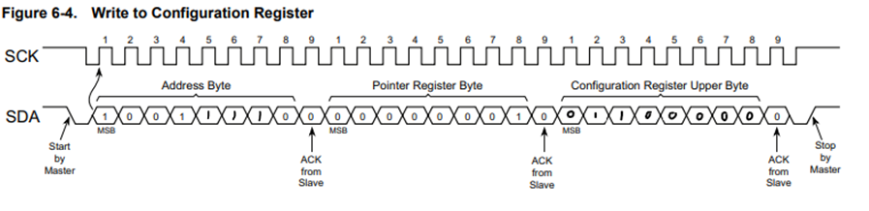
   2. 10011110 00000001 01100000
2. Set Pointer Register to “Temperature Register”
   1. 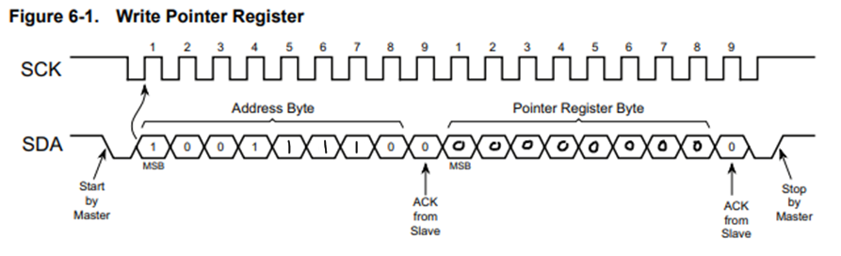
   2. 10011110 00000000
3. Read the Temperature Register
   1. 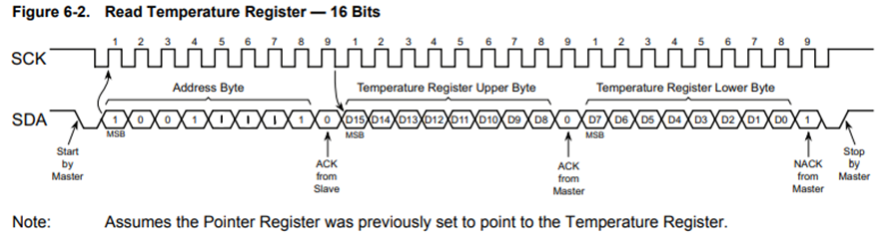
   2. 10011111 *Read(D15:D8)* 0 *Read(D7:D0)* 1
4. Convert Temperature Register Value to Actual Usable Number
 $B_{temp}=D_{15}:D_{4}$

  1. *Convert $B_{temp}$ to Decimal (Not necessary in code)*

$R=0.0625$

$D_{tempC}=B_{temp}*R$

$\left(D_{tempC}*\frac{9}{5}\right)+32=D_{tempF}$